Modify ISO

# Overview

Modify ISO fetches ISO Details saved as a configuration element and modify the existing list. Through this one can change the existing ISOs data.

# Goal

It is prepared to achieve automated modification of existing ISOs which earlier was being done manually.

# Solution/Logic Design

Fetch ISO Details

ResourceConfiISOFile(Configuration Element)

Execute actions “getISONames”,”getISODescription”,”getISOPath”

Fetch array of ISO names, their corresponding Description, Path value

Get modified Description and path value corresponding to a ISO name

Update the ISO Details

end

# Properties

* ISO name – Name of the ISO
* ISO Path – Path of the ISO
* ISO Description – description of the ISO

Dependencies

# Related Actions

* getISOkeys – It fetches the array of ISO names and provides as a drop down.
* getISOValues – It fetches path value corresponding to any ISO name.
* getISODescription – It fetches description corresponding to any ISO name.

# Related Workflows

Not Applicable

# Related Configuration Elements

* ResourceConfISOFile – Configuration element which contains ISO Details from which data needs to be modified, updated or deleted.

# Attributes

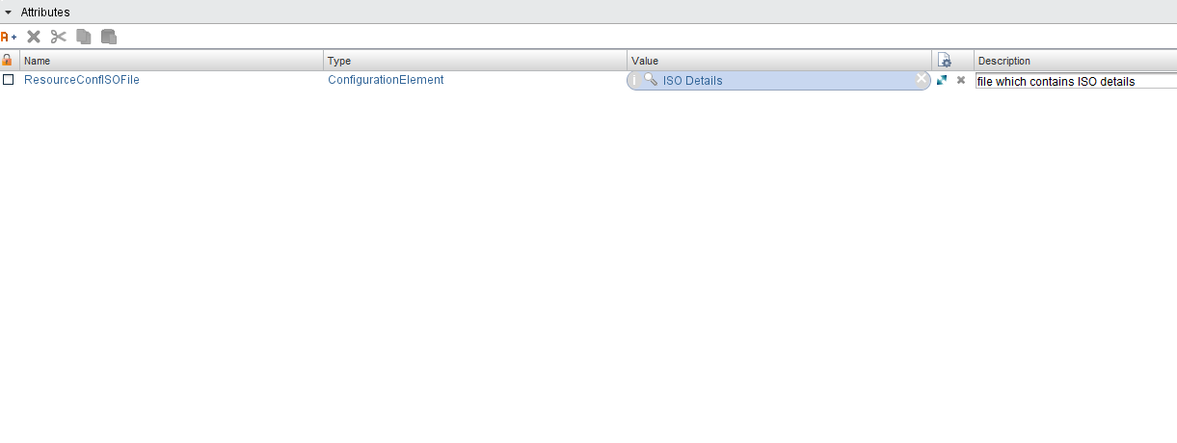

# Inputs

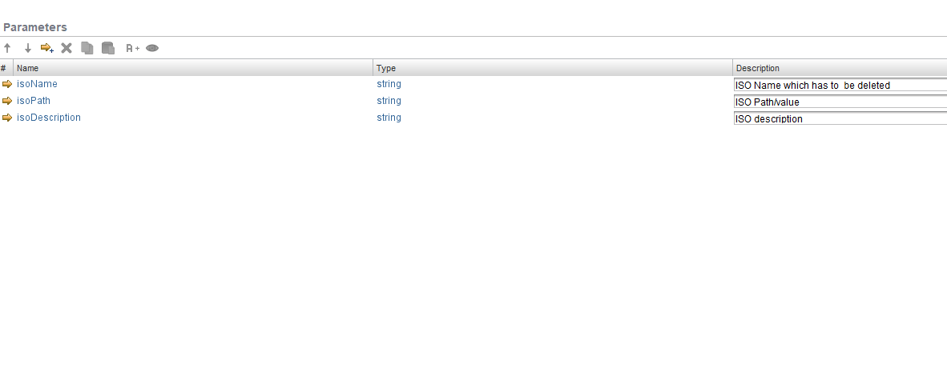

# Future Scope

It can be extended to:

* ISO details can be in different modes like a CSV file, Text file etc. .